Image | 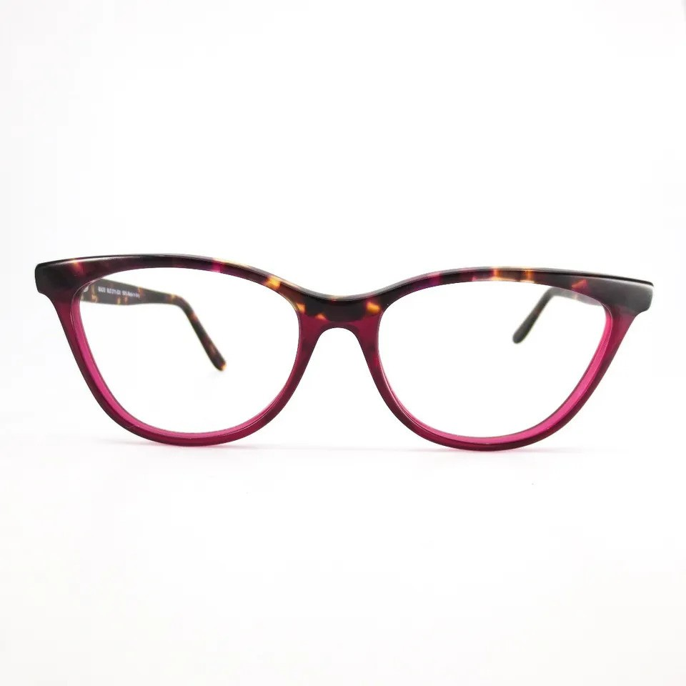
Brand | TIFFANY & CO.
Model Name | MJ 02111
Price | RS 1499
PRODUCT DETAILS

